Code for insertOne()  
*for create operation*

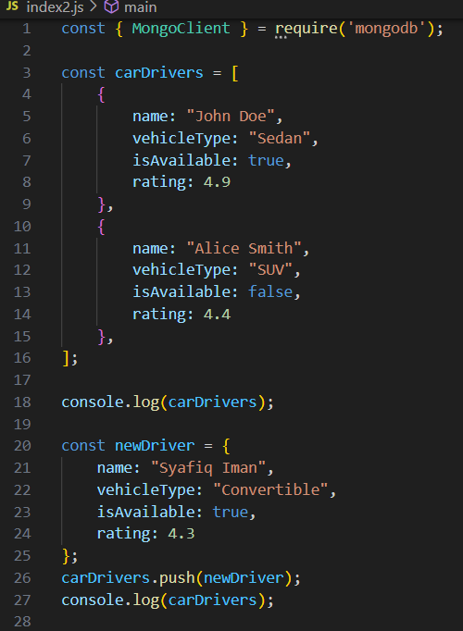

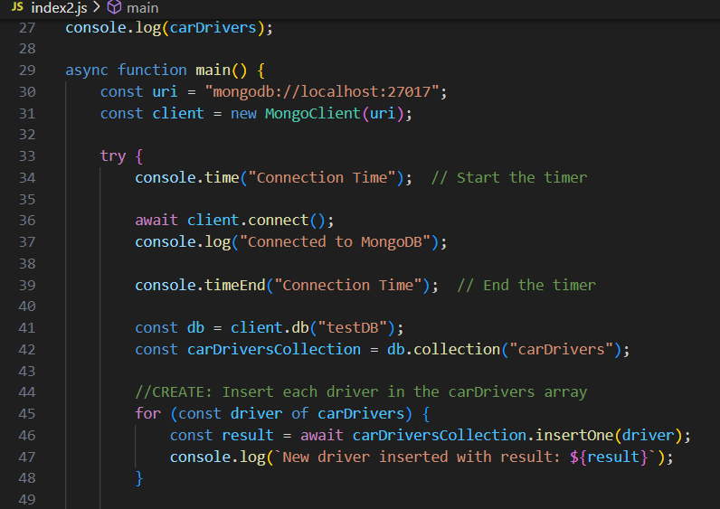

Output for insertOne()  
*for create operation*

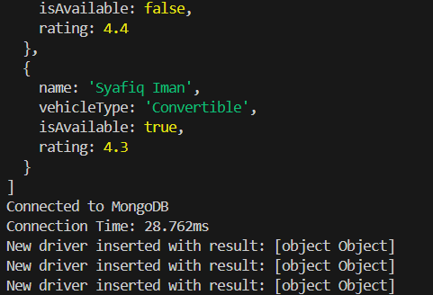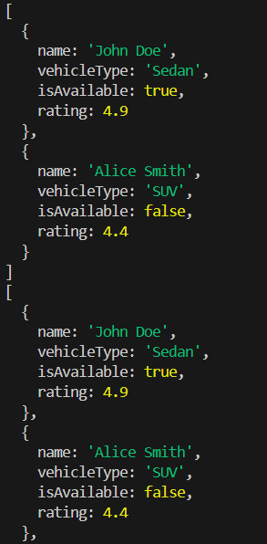

Output for insertOne() at MongoDB  
*for create operation*

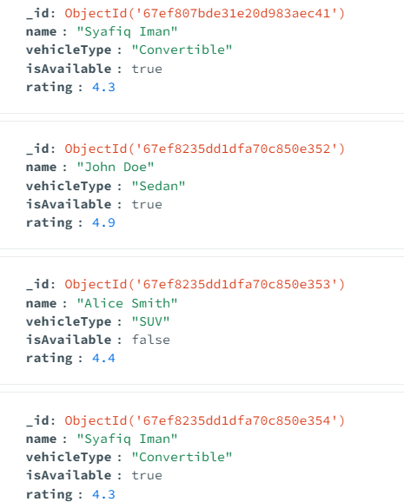

Code for find()  
*for read operation*

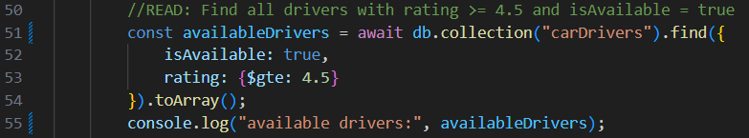

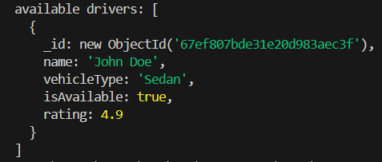Output for find()  
*for read operation*

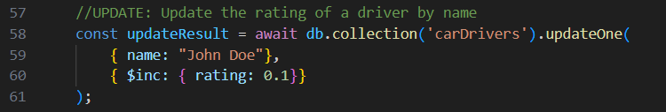Code for updateOne() at VS Code ad aMongoDB  
*for update operation*

Output for updateOne() at VS Code and MongoDB  
*for update operation*

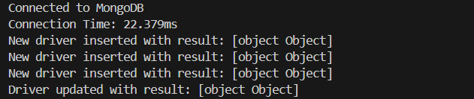

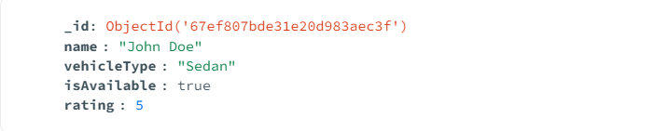

Code for deleteOne()  
*for delete operation*

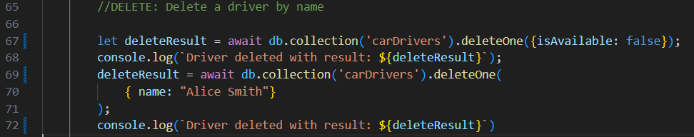

Output for deleteOne()  
*for delete operation*

